Document title page
Software Requirement Specifications
AI-Based Job Market Intelligence and Resume Analysis System


Submitted by:
Muhammad Shahid (S23BINFT1E02054)

Submitted to
Dr. Musarat Karim

Department of Information Technology
Faculty of Computing
The Islamia University of Bahawalpur

Meetings Details
Sr No | Details | Date | Techer Signature
1 | Discussed project idea and basic SRS structure, received initial feedback. | 10/4//2026
2 | Defined detailed requirements and got suggestions for improvement. | 19/4/2026
3 | Finalized SRS, applied changes, and received approval. | 30/4/2026

Summary
This document presents the Software Requirements Specification for an AI-Based Job Market Intelligence and Resume Analysis System. The system is designed to analyze current job market trends and provide valuable insights to users regarding in-demand skills, roles, and industry requirements. It assists job seekers in evaluating their resumes using advanced artificial intelligence techniques and provides personalized feedback to improve their chances of employment. The platform compares user resumes with real-time job market data, identifies missing skills, and suggests relevant improvements and learning paths. Furthermore, the system helps users make better career decisions by highlighting suitable job opportunities based on their profiles. It also supports employers by offering insights into candidate suitability and matching qualifications with job requirements. The system aims to bridge the gap between job seekers and market demands through intelligent data analysis. Overall, it enhances the recruitment process, improves resume quality, and supports effective career planning through accurate and data-driven recommendations.

Table of Contents software requirements specification

Table of Contents
Table of Contents .........................................................................................................
Revision History ..........................................................................................................
Give here the brief revision history of this SRS document .........................................................................................
Chapter 1. ..................................................................................................................7
1. Introduction .......................................................................................................7
1.1 Purpose ....................................................................................................................................................................7
1.2 Document Conventions ................................................................................... …….........................................7
1.3 Intended Audience and Reading Suggestions ........................................................................................ 7
1.4 Product Scope....................................................................................................................................................... 8
1.5 References ...............................................................................................................................................................8
Chapter 2. ..................................................................................................................8
2. Overall Description .............................................................................................8
2.1 Product Perspective ..................................................................................................................................8
2.2 Product Functions.................................................................................................................................... 9
2.3 User Classes and Characteristics ........................................................................................................ 9
2.4 Operating Environment ......................................................................................................................... 9
2.5 Design and Implementation Constraints ........................................................................................... 10
2.6 User Documentation ................................................................................................................................10
2.7 Assumptions and Dependencies .............................................................................................,..............10
Chapter 3. .................................................................................................................10
3. External Interface Requirements .........................................................................11
3.1 User Interfaces .........................................................................................................................................11
3.2 Hardware Interfaces ..............................................................................................................................11
3.3 Software Interfaces .................................................................................................................................11
3.4 Communications Interfaces ..................................................................................................................12

Chapter 4. ................................................................................................................. 13
4. System Features .................................................................................................. 13

4.1 System Feature 1: Job Market Intelligence Engine……………………………………………….13

4.1.1 Description and Prior ............................................................................................................................. 13

4.1.2 Functional Requirements…................................................................................................................... 13

4.2 System Feature 2: AI-Powered Resume Analysis Engine……………….….......................13

4.2.1 Description and Priority…………......................................................................................................... 13

4.2.2 Functional Requirements………............................................................................................................13

4.3 System Feature 3: Intelligent Job-to-Candidate Matching..................................................14

4.3.1 Description and Priority…….................................................................................................................14

4.3.2 Functional Requirements………….......................................................................................................14

4.4 System Feature 4: Career Path Recommendation Module……..........................................15

4.4.1 and Priority Description…………........................................................................................................15

4.4.2 Functional Requirements…………......................................................................................................15

4.5 System Feature 5: Employer Analytics and Talent Intelligence Dashboard……..................15

4.5.1 Description and Priority…………..........................................................................................................15

4.5.2 Functional Requirements…………......................................................................................................15
Chapter 5. ............................................................................................................... 16
5. System Use Cases ............................................................................................. 16
5.1 System level Use Case Diagram ............................................................................................................ 16

5.1.1 Diagram 1 — Job Seeker Use Cases.............................................................................................17

5.1.2 Diagram 2 — Employer / Recruiter Use Cases....................................................................................18

5.1.3 Diagram 3 — System Administrator Use Cases..................................................................................19

5.1.4 Diagram 4 — AI/ML Engine Use Cases (Internal Actor) ..................................................................20
Chapter 6. .................................................................................................................21
6. Other Nonfunctional Requirements ......................................................................21
6.1 Performance Requirements ..................................................................................................................... 21
6.2 Safety Requirements ................................................................................................................................... 21
6.3 Security Requirements ............................................................................................................................... 21
6.4 Software Quality Attributes ...................................................................................................................... 22
6.5 Business Rules ............................................................................................................................................... 22
Chapter 7. .................................................................................................................23
7. Other Requirements ...........................................................................................23

7.1 Internationalization and Localization..........................................................................................23

7.2 Data Retention and Archival.........................................................................................................23

7.3 Ethical AI Requirements...............................................................................................................23

7.4 Compliance Requirements.............................................................................................................23
Appendix A: Glossary .......................................................................................................................................... 25
Appendix B: Analysis Models ............................................................................................................................. 25
Appendix C: To Be Determined List ................................................................................................................ 25
Appendix D: Refference........................................................................................................................................26

Chapter 1 — Introduction

1.1 Purpose
This Software Requirements Specification (SRS) document defines the complete functional and non-functional requirements for the AI-Based Job Market Intelligence and Resume Analysis System (AJMIRAS). The document serves as the authoritative reference for developers, testers, project managers, and stakeholders throughout the software development lifecycle.
The primary purpose of AJMIRAS is to leverage artificial intelligence and machine learning techniques to analyze the current job market landscape and evaluate candidate resumes intelligently, providing actionable insights to both job seekers and employers.

1.2 Document Conventions
This document follows the IEEE 830 standard for Software Requirements Specifications. The following conventions are used:
- Bold text indicates critical requirements or important terms.
- SHALL — indicates a mandatory requirement. (2.4,2.5,2.6)
- SHOULD — indicates a recommended but not mandatory requirement.
- TBD — To Be Determined (items requiring further analysis).(Appendex B)
- FR — Functional Requirement identifier prefix.(Chap no 4)
- NFR — Non-Functional Requirement identifier prefix.(Chap no 6)

1.3 Intended Audience and Reading Suggestions
This document is intended for the following audiences:
Audience | Relevant Sections
Project Managers | Chapters 1, 2, 6
Software Developers | Chapters 3, 4, 5
QA / Test Engineers | Chapters 4, 5, 6
UI/UX Designers | Chapters 3, 5
Business Stakeholders | Chapters 1, 2, 7
System Architects | Chapters 2, 3, 4

1.4 Product Scope
AJMIRAS is a web-based intelligent platform that integrates AI-driven job market analysis with automated resume evaluation capabilities. The system encompasses the following core domains:
- Real-time job market trend analysis and skill demand forecasting.
- AI-powered resume parsing, scoring, and improvement recommendations.
- Job-to-candidate matching using natural language processing (NLP).
- Personalized career pathway recommendations for job seekers.
- Employer-side analytics for talent acquisition decision support.
- Dashboard and reporting modules for all user types.

The system is intended for deployment as a SaaS (Software as a Service) platform, accessible via modern web browsers and mobile applications.

1.5 References
- IEEE Std 830-1998 — IEEE Recommended Practice for Software Requirements Specifications.
- Anthropic Claude API Documentation — for AI model integration.
- O*NET OnLine (https://www.onetonline.org) — Occupational Information Network for job role taxonomies.
- LinkedIn Economic Graph Research — Job market trend data source.
- NIST SP 800-53 — Security and Privacy Controls for Information Systems.
- WCAG 2.1 — Web Content Accessibility Guidelines.

Chapter 2 — Overall Description

2.1 Product Perspective
AJMIRAS is a standalone cloud-based SaaS platform designed to operate as an independent system while integrating with third-party data sources such as job boards, LinkedIn, government labor statistics, and ATS (Applicant Tracking Systems). The system is composed of three major subsystems:
- Job Market Intelligence Engine: Collects, processes, and analyzes job postings and labor market data.
- Resume Analysis Engine: Parses and evaluates resumes using NLP models and industry benchmarks.
- Recommendation & Reporting Module: Generates personalized insights and career pathway suggestions.

The platform interfaces with external systems via RESTful APIs and follows a microservices architecture to ensure scalability and maintainability.

2.2 Product Functions
At a high level, AJMIRAS provides the following major functions:
- Job Market Intelligence — Aggregates job postings from multiple sources; identifies trends in skill demand, salary ranges, and industry growth.
- Resume Parsing and Scoring — Automatically extracts structured data from resumes in PDF, DOCX, and plain-text formats; scores against target job descriptions.
- AI-Powered Job Matching — Matches candidate profiles to relevant job openings using semantic similarity and machine learning models.
- Career Path Recommendations — Provides personalized upskilling roadmaps, certification suggestions, and gap analysis reports.
- Employer Analytics Dashboard — Supplies recruiters with real-time hiring market data, candidate pool analytics, and diversity metrics.
- User Account Management — Supports role-based access control for job seekers, employers, and system administrators.

2.3 User Classes and Characteristics
User Class | Description | Technical Expertise
Job Seeker | Individuals actively or passively seeking employment; primary consumers of resume analysis and job matching features. | Low to Medium
Employer / Recruiter | HR professionals and hiring managers using the platform for talent intelligence and candidate pipeline analysis. | Medium
Career Coach | Professional coaches using platform data to advise clients on career transitions and skill development. | Medium to High
System Administrator | IT personnel responsible for platform configuration, user management, and system monitoring. | High
Data Analyst | Internal users who consume raw market intelligence data and generate custom reports. | High

2.4 Operating Environment
AJMIRAS shall operate in the following environment:
- Server-Side: Cloud infrastructure (AWS / Azure / GCP) running containerized microservices via Docker and Kubernetes.
- Database: PostgreSQL (relational data), MongoDB (document storage), Elasticsearch (search index), Redis (caching).
- AI/ML: Python-based ML pipeline with PyTorch/TensorFlow; integration with large language model APIs for NLP tasks.
- Client-Side: React.js single-page application; compatible with Chrome 110+, Firefox 110+, Edge 110+, Safari 15+.
- Mobile: Progressive Web Application (PWA) with responsive design; native iOS and Android apps (Phase 2).
- Connectivity: Minimum 1 Mbps internet connection required for standard use.

2.5 Design and Implementation Constraints
- All AI models processing personal data must comply with GDPR and applicable regional data protection laws.
- Resume data shall not be stored beyond the user-defined retention period without explicit consent.
- The system shall be built on open standards to avoid vendor lock-in; proprietary AI API dependencies must have documented fallback strategies.
- The platform shall adopt a RESTful API-first design to ensure interoperability with third-party ATS systems.
- Response time for AI-powered resume scoring shall not exceed 10 seconds for 95% of requests.

2.6 User Documentation
The following documentation shall be delivered as part of the product:
- User Manual (Job Seeker) — Onboarding guide, resume upload, and job matching tutorials.
- User Manual (Employer/Recruiter) — Dashboard setup, candidate filtering, and report generation guide.
- Administrator Guide — System configuration, user management, and audit log procedures.
- API Reference Documentation — For third-party integrators; available via Swagger/OpenAPI specification.
- In-App Tooltips and Contextual Help — Integrated guidance throughout the UI.

2.7 Assumptions and Dependencies
The following assumptions underpin this specification:
- Assumption 1: Job posting data from third-party sources (Indeed, LinkedIn, Glassdoor) will be available via licensed API agreements.
- Assumption 2: Users will provide accurate information during profile creation and resume upload.
- Assumption 3: An internet connection is required to use all features; offline functionality is out of scope for Phase 1.
- Assumption 4: The AI models used for NLP and scoring will be available and performant as per vendor SLAs.
- Dependency 1: NLP services depend on access to a commercial or open-source LLM API (e.g., Anthropic Claude, OpenAI GPT-4).
- Dependency 2: Market data aggregation depends on partnerships with job board data providers.
- Dependency 3: Email notification services depend on a third-party SMTP provider (e.g., SendGrid, AWS SES).

Chapter 3 — External Interface Requirements

3.1 User Interfaces
The system shall provide the following UI components:
- UI-01: Landing Page — Marketing homepage with sign-up, login, and feature overview.
- UI-02: Job Seeker Dashboard — Personalized feed of job matches, resume score, and career suggestions.
- UI-03: Resume Upload & Analysis View — Drag-and-drop upload, real-time parsing progress, and scored results with improvement tips.
- UI-04: Job Market Intelligence View — Interactive charts showing skill trends, salary heatmaps, and geographic demand maps.
- UI-05: Employer Analytics Dashboard — Candidate pipeline metrics, market benchmarks, and export functionality.
- UI-06: Settings & Profile Management — Account details, privacy controls, and notification preferences.
- UI-07: Admin Console — User management, system configuration, and audit logs.

All UI components shall conform to WCAG 2.1 Level AA accessibility standards and support both light and dark modes.

3.2 Hardware Interfaces
AJMIRAS is a software-only system and does not directly interact with custom hardware. However, the following hardware constraints apply:
- Server: Minimum 4 vCPU, 16 GB RAM per application node; auto-scaling enabled via cloud provider.
- Client Device: Any device capable of running a modern web browser; minimum display resolution of 360x640 px supported.
- File Input: Standard keyboard and mouse or touch interface for resume upload; camera access for document scanning (mobile, Phase 2).

3.3 Software Interfaces
Interface | Type | Protocol | Purpose
Job Board APIs (Indeed, LinkedIn) | External REST API | HTTPS/JSON | Aggregate job postings for market intelligence
LLM API (Claude / GPT-4) | External REST API | HTTPS/JSON | NLP-powered resume analysis and scoring
ATS Integrations (Workday, Greenhouse) | External REST API | HTTPS/JSON | Sync candidate data with employer ATS
OAuth 2.0 (Google, LinkedIn) | External Auth Protocol | HTTPS | Single Sign-On (SSO) for user authentication
PostgreSQL 15 | Internal Database | TCP/SQL | Structured data storage (users, jobs, scores)
Elasticsearch 8.x | Internal Service | HTTP/REST | Full-text search for job and resume data
Redis 7.x | Internal Cache | TCP | Session caching and rate limiting
SendGrid / AWS SES | External Email API | HTTPS/JSON | Transactional and notification emails

3.4 Communications Interfaces
- All external communications shall use HTTPS (TLS 1.3 or above) to ensure data confidentiality in transit.
- WebSocket connections shall be used for real-time dashboard updates and live resume scoring progress notifications.
- REST APIs shall follow OpenAPI 3.0 specification and support JSON as the primary data exchange format.
- Email notifications shall comply with CAN-SPAM Act and GDPR requirements, including unsubscribe mechanisms.
- Internal microservices shall communicate via a message queue (RabbitMQ / Apache Kafka) for asynchronous processing tasks such as bulk resume scoring and market data ingestion.

Chapter 4 — System Features

4.1 System Feature 1: Job Market Intelligence Engine

4.1.1 Description and Priority
The Job Market Intelligence Engine aggregates and analyzes real-time job postings from multiple data sources to produce actionable labor market insights. This is a HIGH priority feature as it forms the data foundation for all other system capabilities.

4.1.2 Functional Requirements
ID | Requirement | Priority
FR-1.1 | The system SHALL collect job postings from at least five external data sources via API integration. | High
FR-1.2 | The system SHALL refresh market data at minimum every 24 hours and support on-demand refresh. | High
FR-1.3 | The system SHALL classify job postings by industry, role, location, experience level, and required skills using NLP. | High
FR-1.4 | The system SHALL display salary range distributions per job title and location using aggregated data. | Medium
FR-1.5 | The system SHALL generate trending skill reports showing the top 20 in-demand skills by industry over selectable time periods. | High
FR-1.6 | The system SHALL provide geographic heatmaps showing job demand density by region. | Medium
FR-1.7 | The system SHALL detect emerging job roles and declining roles based on posting volume trends. | Medium

4.2 System Feature 2: AI-Powered Resume Analysis Engine

4.2.1 Description and Priority
The Resume Analysis Engine parses uploaded resumes and evaluates them using AI models against industry benchmarks and target job descriptions. This is a HIGH priority feature central to the job seeker value proposition.

4.2.2 Functional Requirements
ID | Requirement | Priority
FR-2.1 | The system SHALL accept resume uploads in PDF, DOCX, and plain-text (TXT) formats. | High
FR-2.2 | The system SHALL extract structured data from resumes including: contact info, work experience, education, skills, and certifications. | High
FR-2.3 | The system SHALL score resumes on a scale of 0–100 based on completeness, relevance, and ATS compatibility. | High
FR-2.4 | The system SHALL provide section-level feedback highlighting weaknesses and improvement suggestions. | High
FR-2.5 | The system SHALL detect keyword gaps when comparing a resume to a specific job description. | High
FR-2.6 | The system SHALL identify and flag potential bias indicators (e.g., age, gender markers) to support fair hiring. | Medium
FR-2.7 | The system SHALL support resume analysis in English, with French and Spanish in Phase 2. | Medium
FR-2.8 | The system SHALL complete single-resume analysis within 10 seconds for 95% of requests. | High

4.3 System Feature 3: Intelligent Job-to-Candidate Matching

4.3.1 Description and Priority
The matching engine uses semantic NLP to calculate compatibility scores between candidate profiles and job postings, enabling highly relevant job recommendations beyond simple keyword matching. Priority: HIGH.

4.3.2 Functional Requirements
ID | Requirement | Priority
FR-3.1 | The system SHALL generate a compatibility score (0–100%) for each candidate-job pair using semantic analysis. | High
FR-3.2 | The system SHALL recommend a ranked list of top 20 job matches per candidate, refreshed daily. | High
FR-3.3 | The system SHALL allow candidates to filter matches by location, salary range, job type, and industry. | High
FR-3.4 | The system SHALL enable employers to search the candidate pool using natural language queries. | Medium
FR-3.5 | The system SHALL support configurable weighting of matching criteria (skills, experience, education). | Medium
FR-3.6 | The system SHALL track candidate engagement with job recommendations to improve future suggestions via feedback loop. | Low

4.4 System Feature 4: Career Path Recommendation Module

4.4.1 and Priority Description
This module generates personalized, AI-driven career roadmaps for job seekers, including skill gap analysis, recommended certifications, and projected salary growth. Priority: MEDIUM.

4.4.2 Functional Requirements
ID | Requirement | Priority
FR-4.1 | The system SHALL generate a skill gap report comparing the user's current profile to their target job role. | High
FR-4.2 | The system SHALL recommend online courses and certifications (via Coursera, Udemy, LinkedIn Learning APIs) to close identified skill gaps. | Medium
FR-4.3 | The system SHALL display projected salary growth for recommended career transitions. | Medium
FR-4.4 | The system SHALL provide a visual career timeline showing milestone steps from current to target role. | Low
FR-4.5 | The system SHALL allow users to set target roles and update recommendations dynamically when targets change. | Medium

4.5 System Feature 5: Employer Analytics and Talent Intelligence Dashboard

4.5.1 Description and Priority
A dedicated employer-facing module providing real-time hiring market benchmarks, candidate pool analytics, and recruitment funnel metrics. Priority: HIGH for employer-tier subscriptions.

4.5.2 Functional Requirements
ID | Requirement | Priority
FR-5.1 | The system SHALL display real-time average time-to-hire and cost-per-hire benchmarks by industry and location. | High
FR-5.2 | The system SHALL provide diversity and inclusion metrics for active job postings and the candidate pipeline. | Medium
FR-5.3 | The system SHALL allow employers to post jobs directly through the platform and track application analytics. | High
FR-5.4 | The system SHALL generate exportable reports in PDF and XLSX formats for all analytics modules. | Medium
FR-5.5 | The system SHALL provide AI-generated hiring recommendations based on market conditions and role requirements. | Medium
FR-5.6 | The system SHALL support team-level access with role-based permissions for recruiter teams. | High

Chapter 5: System Use Cases
This chapter presents the system-level use cases for the AI-Based Job Market Intelligence and Resume Analysis System (AJMIRAS). It includes actor identification, system boundary definitions, and four separate use case diagrams — one for each major actor group.

5.1 System Level Use Case Diagrams
The following actors interact with the AJMIRAS system:

Actors:
1. Job Seeker — Primary end user; uploads resumes, views job matches, and accesses career recommendations.
2. Employer / Recruiter — Posts job listings, searches candidates, and accesses market intelligence dashboards.
3. System Administrator — Manages users, monitors system health, and configures integrations.
4. AI/ML Engine — Internal system actor that processes NLP, scoring, and recommendation tasks.
The system boundary for AJMIRAS encompasses all core modules. Based on the actors and their interactions, four separate use case diagrams have been prepared as follows:

5.1.1 Diagram 1 — Job Seeker Use Cases
This diagram illustrates all use cases available to the Job Seeker actor. The Job Seeker can register, upload and analyze their resume, view personalized job matches, explore market trends, receive career path recommendations, identify skill gaps, search and apply for jobs, and receive resume improvement suggestions.

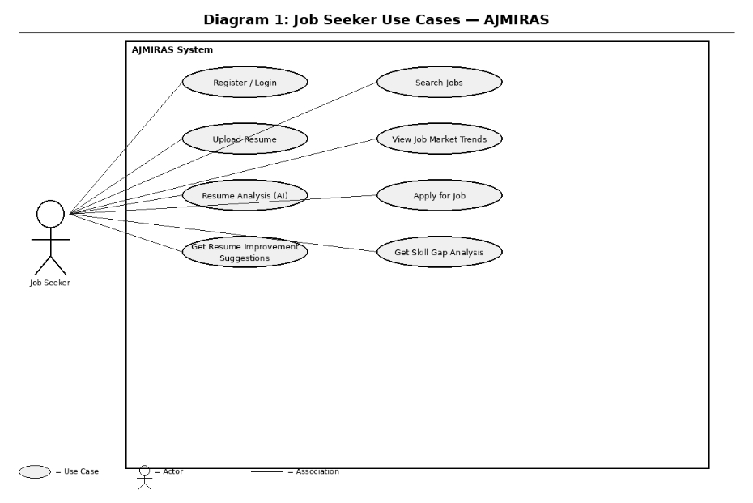
Figure 5.1 — Job Seeker Use Case Diagram

5.1.2 Diagram 2 — Employer / Recruiter Use Cases
This diagram illustrates all use cases available to the Employer / Recruiter actor. The employer can register, post job listings, search and filter the candidate pool, view and contact candidate profiles, access analytics dashboards, and export recruitment reports.

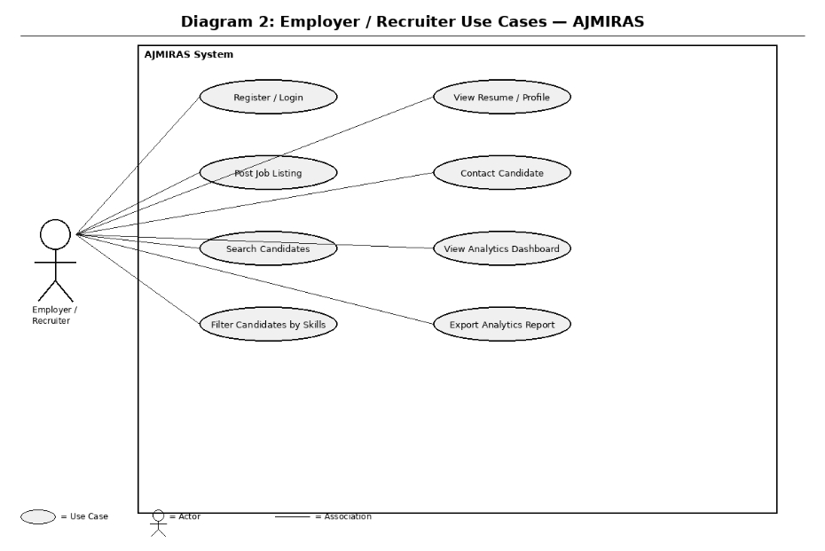
Figure 5.2 — Employer / Recruiter Use Case Diagram

5.1.3 Diagram 3 — System Administrator Use Cases
This diagram illustrates all use cases available to the System Administrator. The administrator manages user accounts, job listings, system settings, audit logs, integrations, and monitors overall AI and system performance.

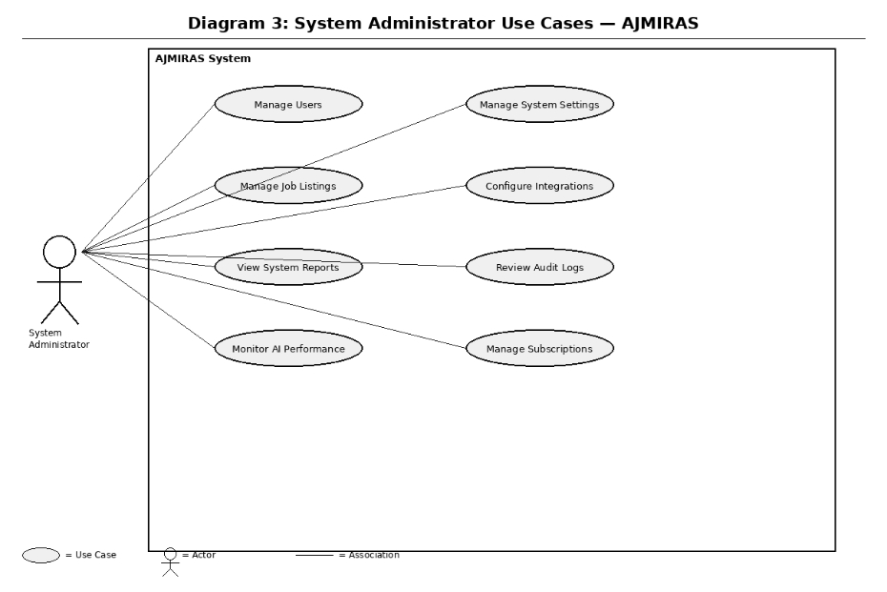
Figure 5.3 — System Administrator Use Case Diagram

5.1.4 Diagram 4 — AI/ML Engine Use Cases (Internal Actor)
This diagram illustrates the internal use cases performed by the AI/ML Engine component. As a system actor, the AI/ML Engine is responsible for resume analysis, ATS scoring, job matching, skill gap identification, market report generation, job trend prediction, career path recommendation, and job description optimization.

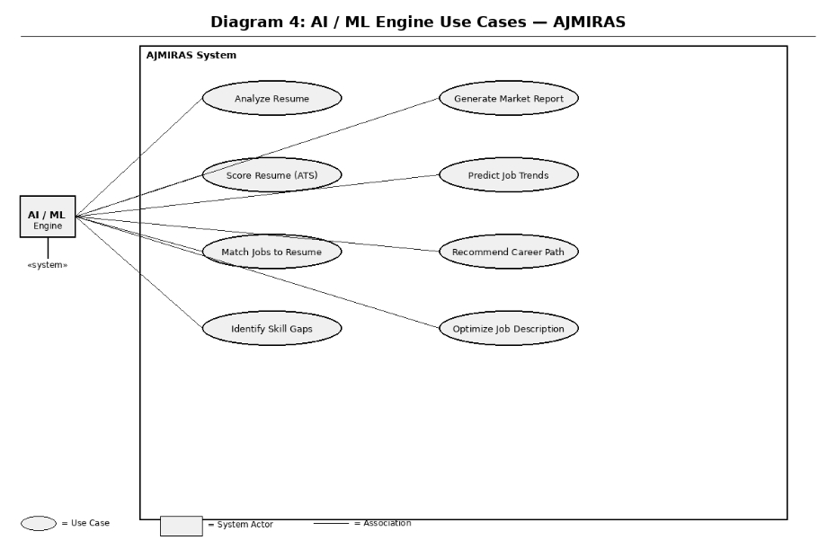
Figure 5.4 — AI/ML Engine Use Case Diagram

Chapter 6 — Other Nonfunctional Requirements

6.1 Performance Requirements
ID | Requirement | Target
NFR-P1 | Resume analysis response time | < 10 seconds for 95% of requests
NFR-P2 | Job market dashboard load time | < 3 seconds on standard broadband
NFR-P3 | Job matching recommendation refresh | Daily; on-demand within 30 seconds
NFR-P4 | System uptime (SLA) | 99.9% availability (< 8.76 hours downtime/year)
NFR-P5 | Concurrent user support | 10,000 simultaneous users without degradation
NFR-P6 | Data ingestion throughput | 50,000 job postings processed per hour
NFR-P7 | API response time (95th percentile) | < 500 ms for all public API endpoints

6.2 Safety Requirements
- NFR-S1: The system shall implement automated data backup every 6 hours with a Recovery Point Objective (RPO) of 6 hours.
- NFR-S2: The system shall achieve a Recovery Time Objective (RTO) of 4 hours in the event of a critical system failure.
- NFR-S3: AI model outputs that influence hiring decisions shall include confidence scores and human-override capabilities to prevent automated adverse employment actions.
- NFR-S4: The system shall log all AI-generated scoring decisions with audit trails to support regulatory compliance and dispute resolution.
- NFR-S5: Automated alerts shall notify administrators of anomalous system behavior within 5 minutes of detection.

6.3 Security Requirements
- NFR-SEC1: All data transmission shall be encrypted using TLS 1.3 or higher.
- NFR-SEC2: All stored personal data (PII) shall be encrypted at rest using AES-256 encryption.
- NFR-SEC3: User authentication shall support multi-factor authentication (MFA) via TOTP or SMS.
- NFR-SEC4: The system shall enforce Role-Based Access Control (RBAC) with the principle of least privilege.
- NFR-SEC5: The system shall conduct automated vulnerability scanning on a weekly basis and address Critical/High severity findings within 72 hours.
- NFR-SEC6: The system shall comply with GDPR (EU), CCPA (California), and PDPA (applicable regions) data privacy regulations.
- NFR-SEC7: Resume and personal data shall not be shared with employers without explicit candidate consent.
- NFR-SEC8: The system shall implement rate limiting and DDoS protection on all public endpoints.

6.4 Software Quality Attributes
Attribute | Requirement
Usability | New users shall be able to complete resume upload and view results within 5 minutes without assistance. SUS score target: > 75.
Reliability | AI model accuracy for skill extraction shall achieve F1-score >= 0.85 on benchmark datasets. Resume scoring consistency: < 5% variance on identical inputs.
Maintainability | All microservices shall have >= 80% unit test coverage. Code shall follow documented style guides. Deployment via CI/CD pipeline.
Scalability | The system architecture shall support horizontal scaling to 10x baseline load using containerized auto-scaling within 5 minutes.
Portability | The platform shall be deployable on AWS, Azure, or GCP without architecture changes. Docker images shall be cloud-agnostic.
Interoperability | All external integrations shall use documented, versioned REST APIs. Breaking changes require 90-day deprecation notice.
Accessibility | All UI components shall conform to WCAG 2.1 Level AA. Screen reader compatibility required for all core user flows.

6.5 Business Rules
- BR-01: Free-tier users are limited to 3 resume analyses per month; Pro-tier users have unlimited analyses.
- BR-02: Employer accounts require verified business email and company registration for activation.
- BR-03: All AI-generated career recommendations shall clearly be labeled as AI-generated and not constitute professional career counseling advice.
- BR-04: Job seekers retain full ownership of their resume data and may request deletion at any time, compliant with the right to erasure under GDPR.
- BR-05: Employers may only contact job seekers who have opted into recruiter outreach.
- BR-06: Job postings containing prohibited discriminatory language (age, gender, religion) shall be automatically rejected by the content moderation module.

Chapter 7 — Other Requirements
This chapter documents additional requirements not captured in previous sections.

7.1 Internationalization and Localization
- The platform shall support UTF-8 character encoding for all user input and stored data to accommodate international names and resume content.
- The UI shall support right-to-left (RTL) text rendering for Arabic and Hebrew in Phase 3.
- Date, currency, and number formats shall adapt to the user's locale settings.

7.2 Data Retention and Archival
- User account data shall be retained for the duration of the account and deleted within 30 days of account closure upon user request.
- Job market aggregated (anonymized) data shall be retained for up to 5 years for trend analysis purposes.
- Audit logs shall be retained for a minimum of 2 years and stored in tamper-evident append-only storage.

7.3 Ethical AI Requirements
- The system shall undergo bias audits on AI scoring and matching models every 6 months, with results disclosed in the product transparency report.
- The resume scoring algorithm shall not use demographic or protected characteristic proxies (e.g., zip code as a socioeconomic proxy) in scoring calculations.
- Users shall have the right to contest AI-generated scores and request human review.

7.4 Compliance Requirements
Regulation / Standard | Applicability | Compliance Action
GDPR (EU 2016/679) | All EU users | Data processing agreements, consent management, DPO designation
CCPA (California) | California residents | Privacy policy updates, opt-out mechanisms, data inventory
ADA / Section 508 | US users | WCAG 2.1 AA compliance for all UI components
ISO/IEC 27001 | Platform-wide | Information security management system certification target
SOC 2 Type II | Enterprise customers | Annual third-party audit of security, availability, confidentiality controls
Equal Employment Opp. Laws | Employer features | Content moderation to prevent discriminatory job postings

Appendix A: Glossary
Term | Definition
ATS | Applicant Tracking System — software used by employers to manage job applications and candidate data.
NLP | Natural Language Processing — AI techniques for analyzing and understanding human language.
SRS | Software Requirements Specification — document describing the behavior and properties of a software system.
LLM | Large Language Model — AI model trained on large text datasets to perform language understanding and generation tasks.
PII | Personally Identifiable Information — data that can be used to identify an individual.
RBAC | Role-Based Access Control — access restriction based on user roles within the organization.
SaaS | Software as a Service — cloud-based software delivery model.
TBD | To Be Determined — item requiring further analysis or decision.
RPO | Recovery Point Objective — maximum acceptable data loss measured in time.
RTO | Recovery Time Objective — maximum acceptable downtime after a system failure.

Appendix B: Analysis Models
The following analysis models support the requirements specified in this document:
- Data Flow Diagrams (DFDs) — to be developed during system design phase (TBD).
- Entity-Relationship Diagrams — to be developed by the database design team (TBD).
- AI Model Architecture Diagrams — ML pipeline design documents (TBD).
- UI Wireframes — to be produced by the UX team prior to Sprint 1 (TBD).

Appendix C: To Be Determined List
ID | Item | Owner | Target Date
TBD-01 | Final selection of LLM API provider(s) for NLP tasks | CTO | Q2 2026
TBD-02 | Third-party job data licensing agreements and cost structure | Business Development | Q2 2026
TBD-03 | Phase 2 mobile app platform strategy (native vs. PWA) | Product Manager | Q3 2026
TBD-04 | Bias audit methodology and third-party auditor selection | AI Ethics Lead | Q3 2026
TBD-05 | Specific salary benchmark data sources and update frequency SLA | Data Team | Q2 2026

Appendix D: References
- IEEE Std 830-1998, IEEE Recommended Practice for Software Requirements Specifications.
- OWASP Application Security Verification Standard (ASVS) v4.0.
- NIST Special Publication 800-53 Rev 5 — Security and Privacy Controls for Information Systems and Organizations.
- Web Content Accessibility Guidelines (WCAG) 2.1, W3C Recommendation.
- General Data Protection Regulation (GDPR), Official Journal of the European Union, 2016.
- California Consumer Privacy Act (CCPA), California Civil Code Section 1798.100.
- Anthropic Claude API Documentation — https://docs.anthropic.com
- OpenAPI Specification 3.0 — https://swagger.io/specification/

